- Install the Solidcam, copy ‘gMilling_Carvera_3x .gpp’ and ‘gMilling_Carvera_3x .vmid’ to the ‘C:\Users\Public\Documents\SolidCAM\SolidCAM2019\GPPTOOL’ directory;
- Load the SolidCAM plug-in, run Solidworks and click: Tools→SolidCAM→SolidCAM Settings, set the post-processing file directory to ‘C:\Users\Public\Documents\SolidCAM\SolidCAM2019\GPPTOOL’,
Set Milling CNC-Controller to: 'gMilling_Carvera_3x', confirm to save;
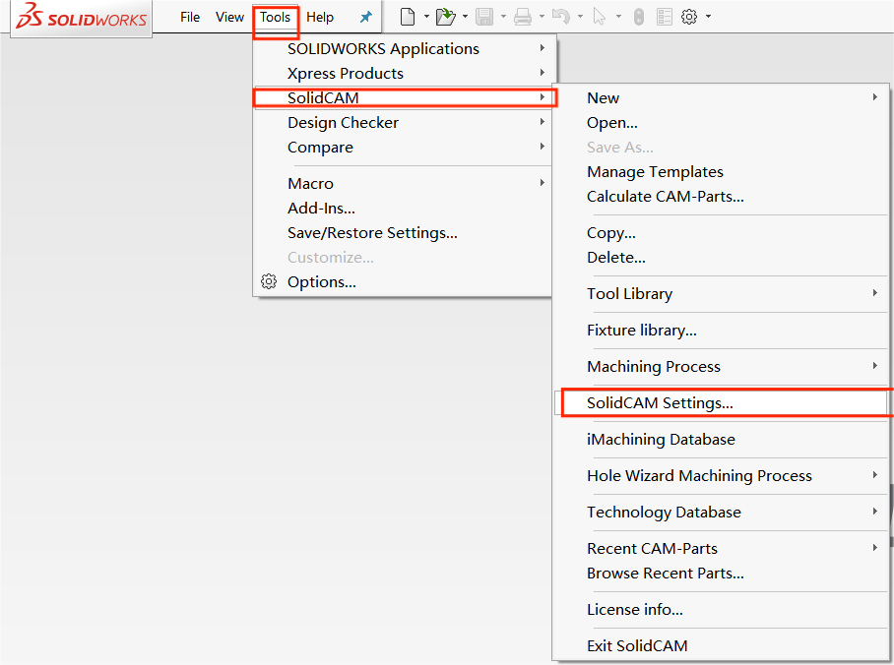
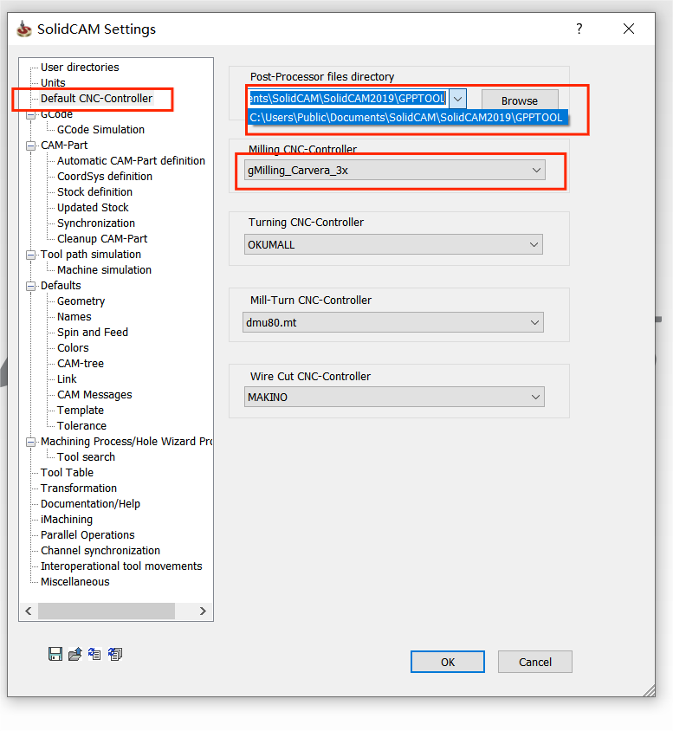
- Set the G code editor as shown in the figure below
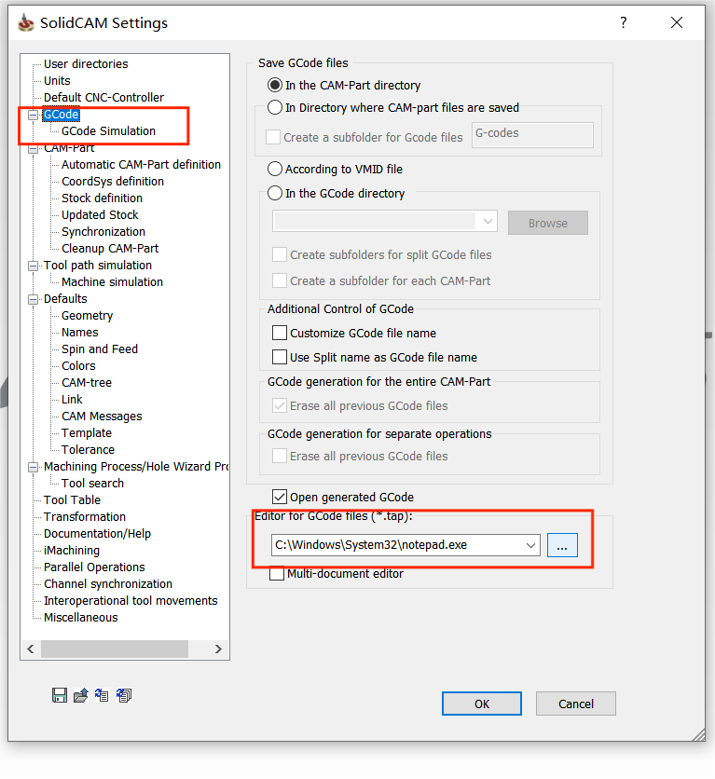

- Create a new milling project, confirm that the CNC machine tool is ‘gMilling_Carvera_3x’, and then design the tool path program by yourself;
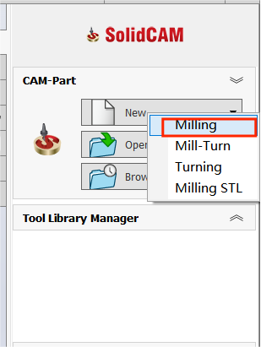
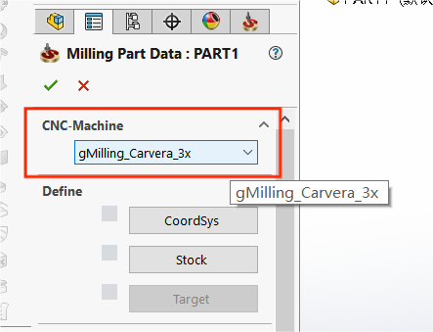
- Generate G codes for the operation, save the file to the ‘C:\Program Files (x86)\CarveraController\gcodes’ directory, and pay attention to the encoding method should be selected as UTF-8.
